CSIT314 Software Development Methodologies - Group Project

Sprint 1 - US1: Log in
Interior Design Platform - User Admin
All diagrams were drawn in draw.io. Open "US1 Log in.drawio" in this folder to edit them - each diagram is its own page in that file. The exported images are in the "diagrams" folder.

Assumptions
- The system is the Interior Design Platform from the project specification. Sprint 1 covers the User Admin's log in / log out and managing user profiles and user accounts (US1-US12).
- A user profile is a user group, e.g. User Admin, Interior Designer, Customer or Platform Manager. It has a name, a description, a list of permissions (what its users can do) and a status (Active or Suspended). Every user account belongs to exactly one user profile and gets that profile's permissions.
- We follow B-C-E: the actor only talks to the boundary (page), the boundary only talks to the controller, and the controller works with the entity classes. There is one controller per use case.
- The boundary checks all the input (required fields, lengths, formats, e.g. not suspending your own profile) and trims spaces, then passes an entity object on. The controller just calls the entity and returns the result. The entity checks for duplicates and the database state (e.g. name already used, only Active rows are changed), then saves.
- Passwords are stored as a hash, never as plain text. verifyCredentials() hashes the typed password and compares it with the stored hash.
- When the login works, LoginPage starts a new session with the user's id, profile id and username. Other pages read the logged-in user from the session, and log out (US2) clears it.
- The same error message is used for every failed login on purpose, so nobody can find out which usernames exist or which accounts are suspended.
- /login is the one login page for every role, and the "Log in as" box picks which role is checked. With User Admin picked, the account's user profile must have the "Manage user accounts" and "Manage user profiles" permissions (REQUIRED_ADMIN_PERMISSIONS). Interior designers, customers and platform managers pick their own role instead (US13, US30, US39); if they leave User Admin picked they get the same error message.
- The page trims the spaces from the username. UserAccount.verifyCredentials() then does every database check in one call: the password hash, the account status, the profile status and the permissions. LoginController only makes that call.

1. User story
Story ID | US1
User story | As a user admin, I want to log in so that I can manage users.
Actor | User Admin
Priority | High
Story points (estimate) | 3
Acceptance criteria | 1. Given I have an active User Admin account, when I enter the right username and password and click "Log in", then I am taken to the User Admin dashboard.  2. Given I enter a wrong username or password, when I click "Log in", then I see "Invalid login details or account suspended" and I stay on the login page.  3. Given my user account or my user profile is suspended, when I try to log in, then I am not logged in and I see the same error message.  4. Given I leave the username or the password empty, when I click "Log in", then I see "Please enter your username and password".  5. The password is hidden (shown as dots) while I type it.  6. Given my account is active but it is not a User Admin account (e.g. a customer), when I log in on this page, then I see "Invalid login details or account suspended" and I am not logged in.
Tasks | #49 Draw Login Use Case Diagram  #50 Write Login Use Case Description  #51 Draw Login BCE Diagram  #52 Draw Login Sequence Diagram  #53 Design Login Wireframe  #54 Write and Execute Login Test Cases

2. Use case diagram
The user story becomes one use case, UC1 Log in. The User Admin is the only actor.
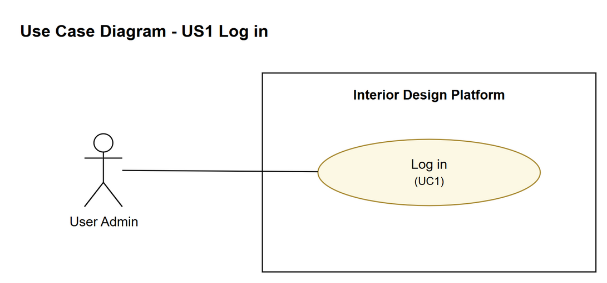
Figure 1: Use case diagram for US1 Log in

3. Use case description
Use case | UC1 Log in
Actor | User Admin
Brief description | The User Admin enters their username and password to get into the system so they can manage user profiles and user accounts.
User story | US1: As a user admin, I want to log in so that I can manage users.
Preconditions | The User Admin already has a user account.  The User Admin is not logged in.
Trigger | The User Admin opens the platform's login page.
Basic flow | 1. The User Admin opens the login page.  2. The system shows the login form (username and password).  3. The User Admin enters their username and password and clicks "Log in".  4. The system checks that both fields are filled in and trims the spaces from the username.  5. The system checks the username and password against the saved user accounts.  6. The system checks that the user account is active.  7. The system checks that the account's user profile is active and is a User Admin profile (it has the "Manage user accounts" and "Manage user profiles" permissions).  8. The system starts a session and takes the User Admin to the User Admin dashboard.
Alternative flows | 4a. The username or password is empty: the system shows "Please enter your username and password" and the database is not checked (back to step 3).  5a. The username does not exist or the password is wrong: the system shows "Invalid login details or account suspended" (back to step 3).  6a. The user account is suspended: the system shows the same message and does not log in.  7a. The user profile is suspended: the system shows the same message and does not log in.  7b. The user profile is not a User Admin profile (e.g. a customer): the system shows the same message and does not log in. Those users pick their own role in "Log in as" (UC13, UC30, UC39).
Postconditions | Success: the User Admin is logged in, a session is started and the dashboard is shown.  Failure: the User Admin is not logged in and stays on the login page.

4. Wireframes
The wireframes were drawn in draw.io. They are low-fidelity: they show the layout and the flow, not the final colours. The orange numbers match the notes under each screen.

4a - Login page
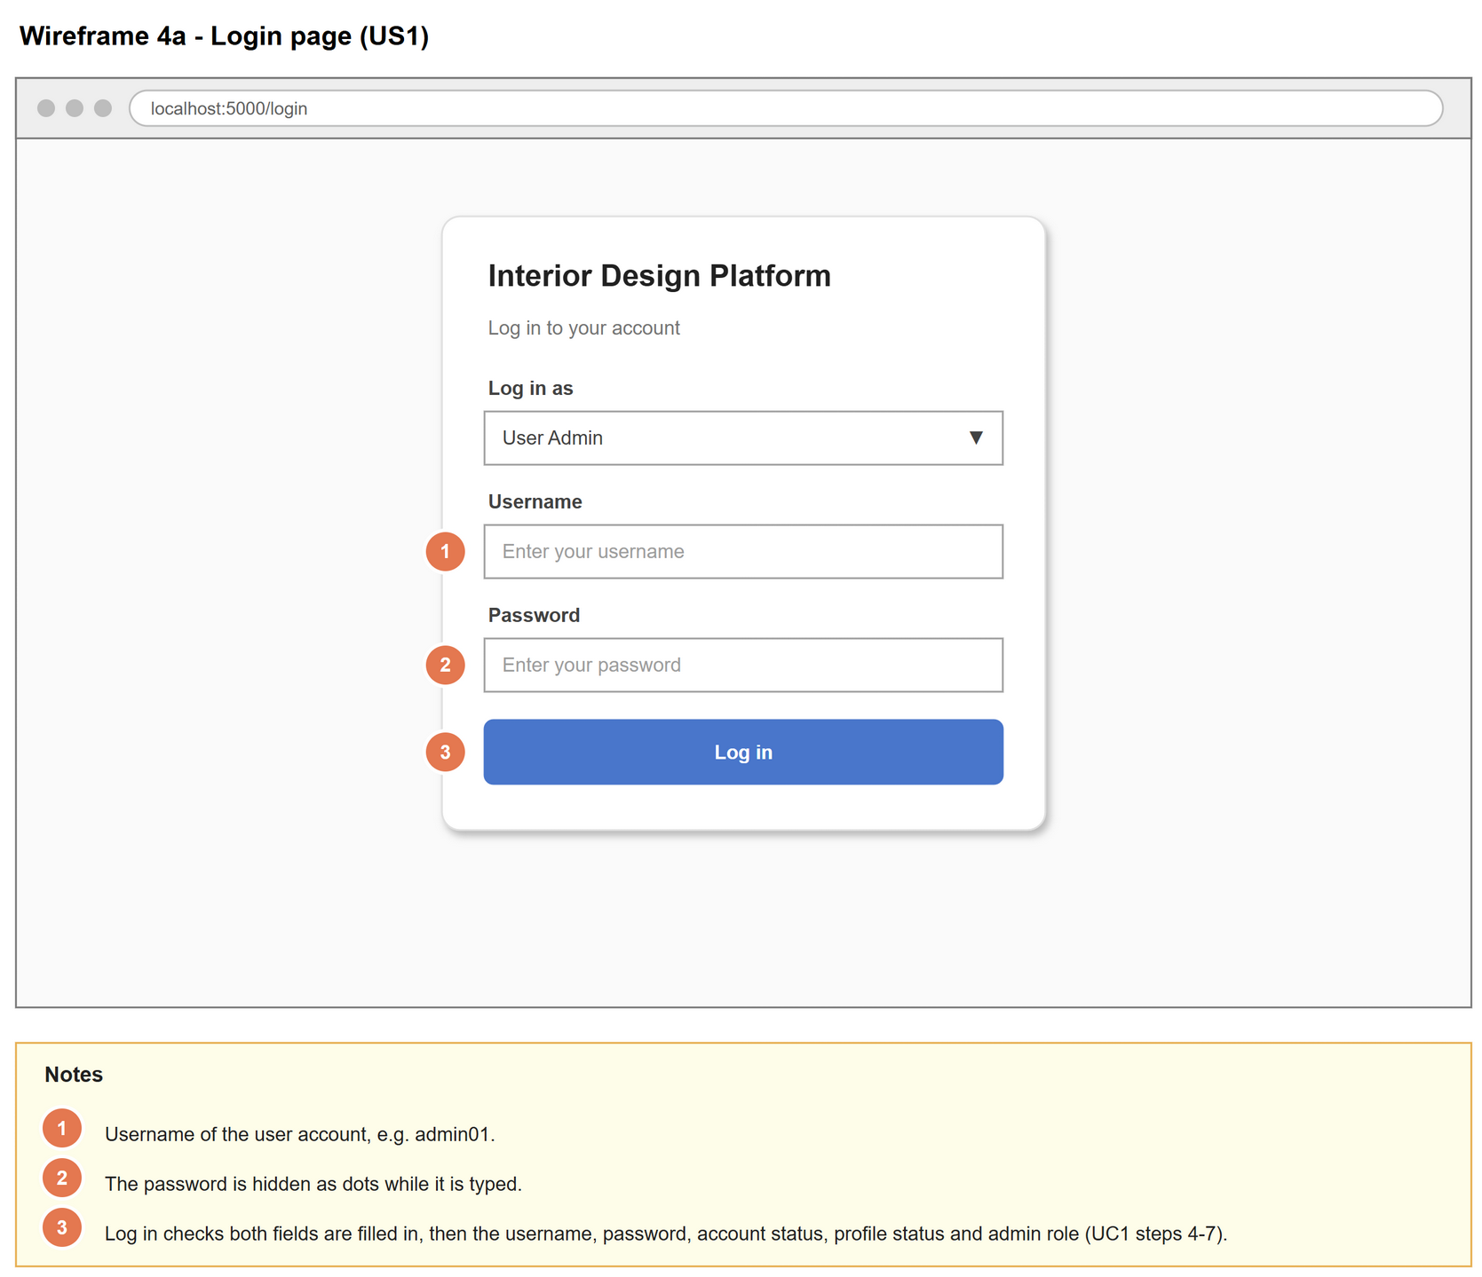
Figure 2: Wireframe 4a - Login page (US1)

4b - Login failed
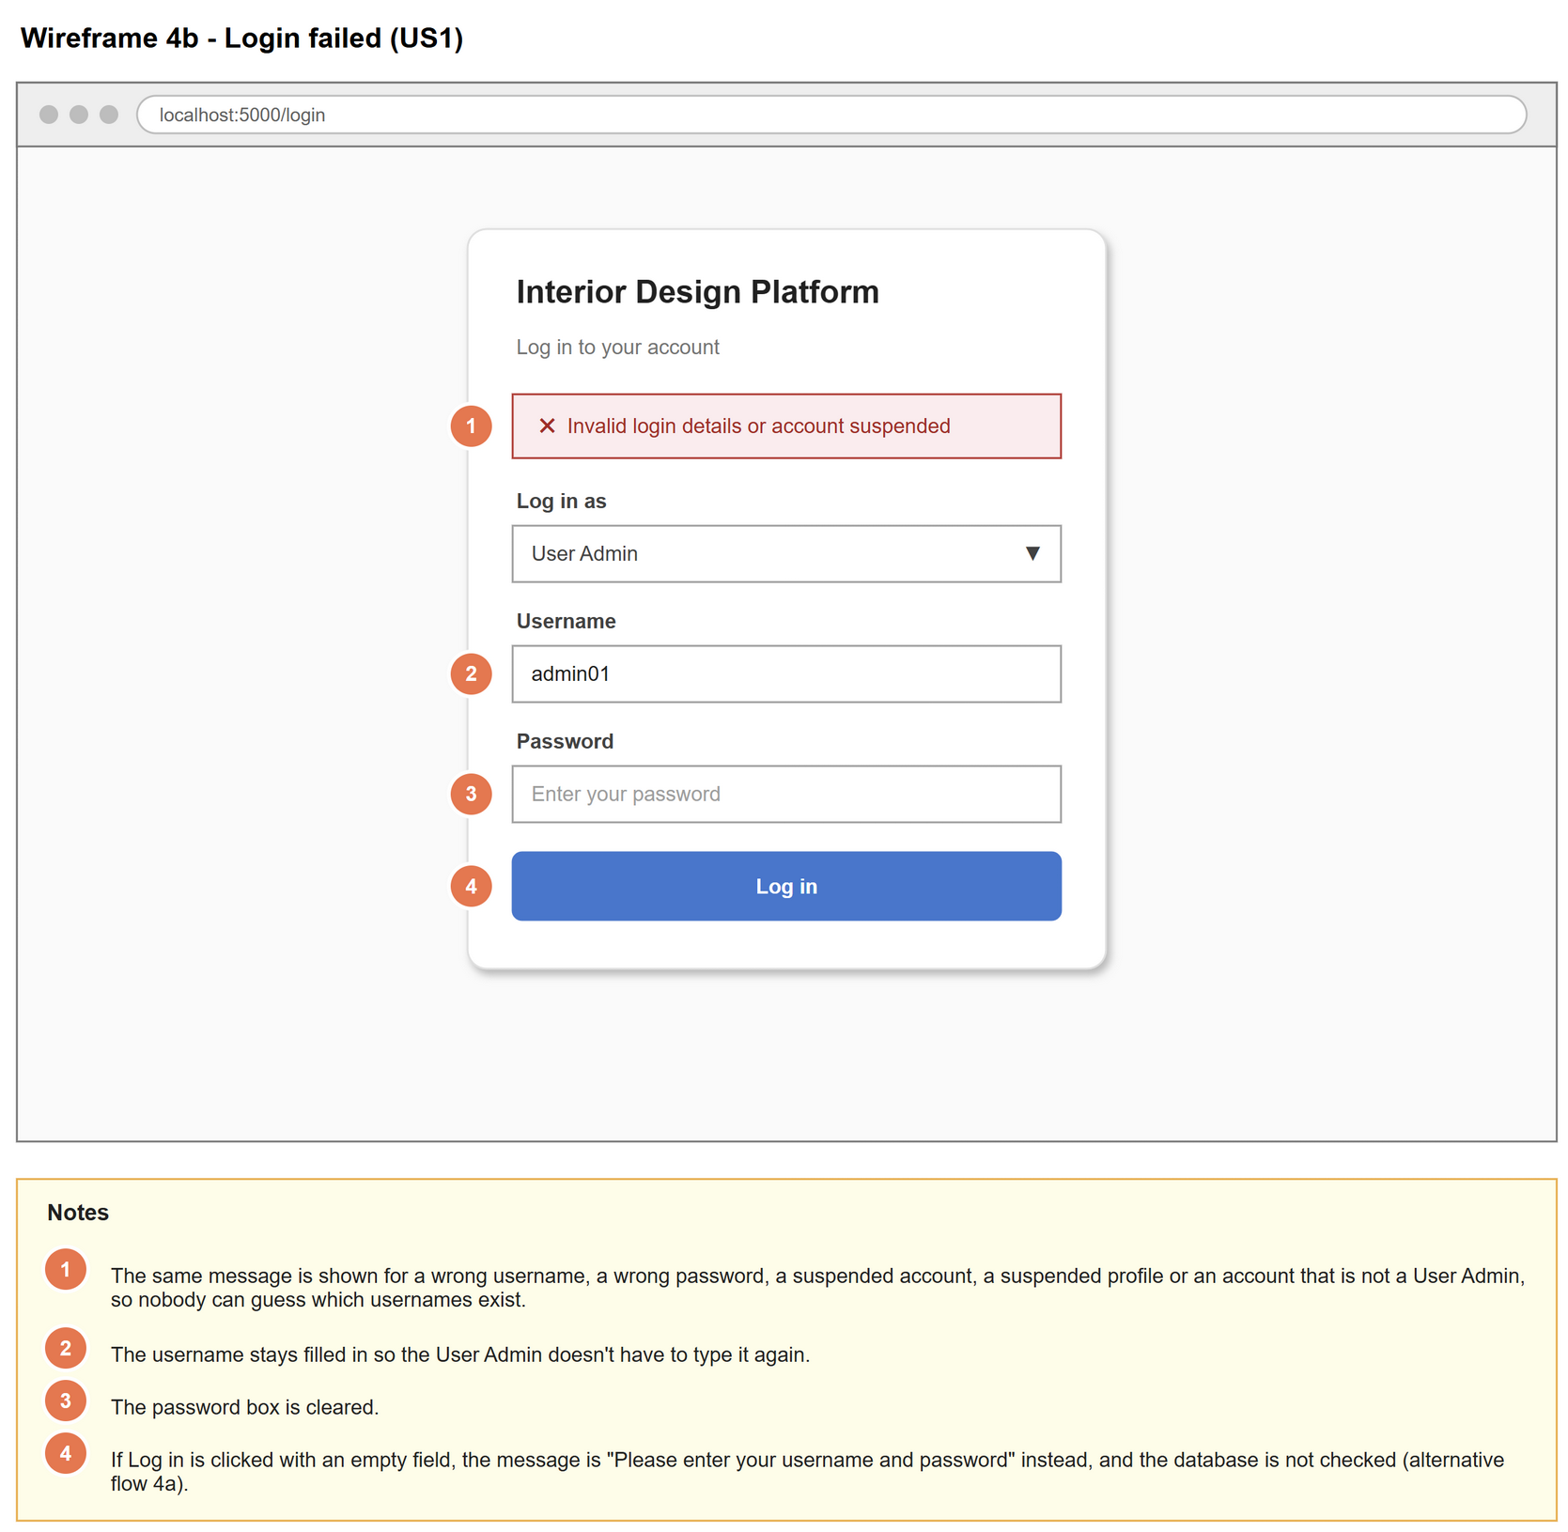
Figure 3: Wireframe 4b - Login failed (US1)

4c - User Admin dashboard after logging in
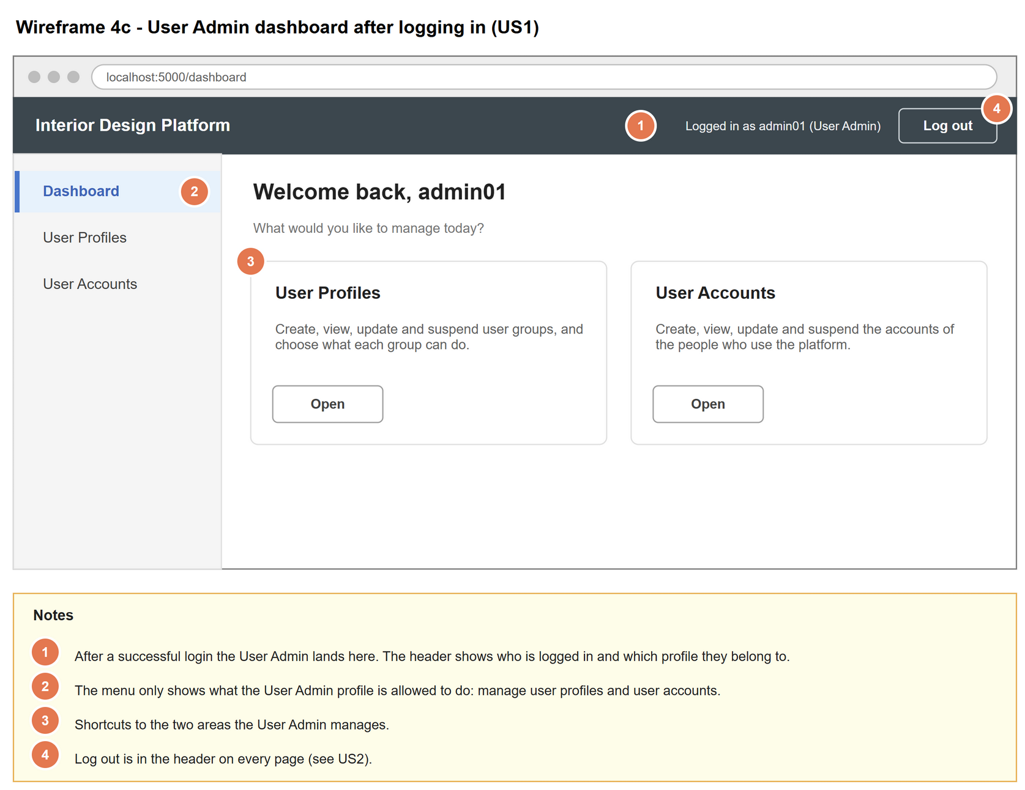
Figure 4: Wireframe 4c - User Admin dashboard after logging in (US1)

5. B-C-E class diagram
The solid arrow means the boundary calls the controller. The dashed arrow means the controller uses the entity class. Only the operations needed for this use case are shown.
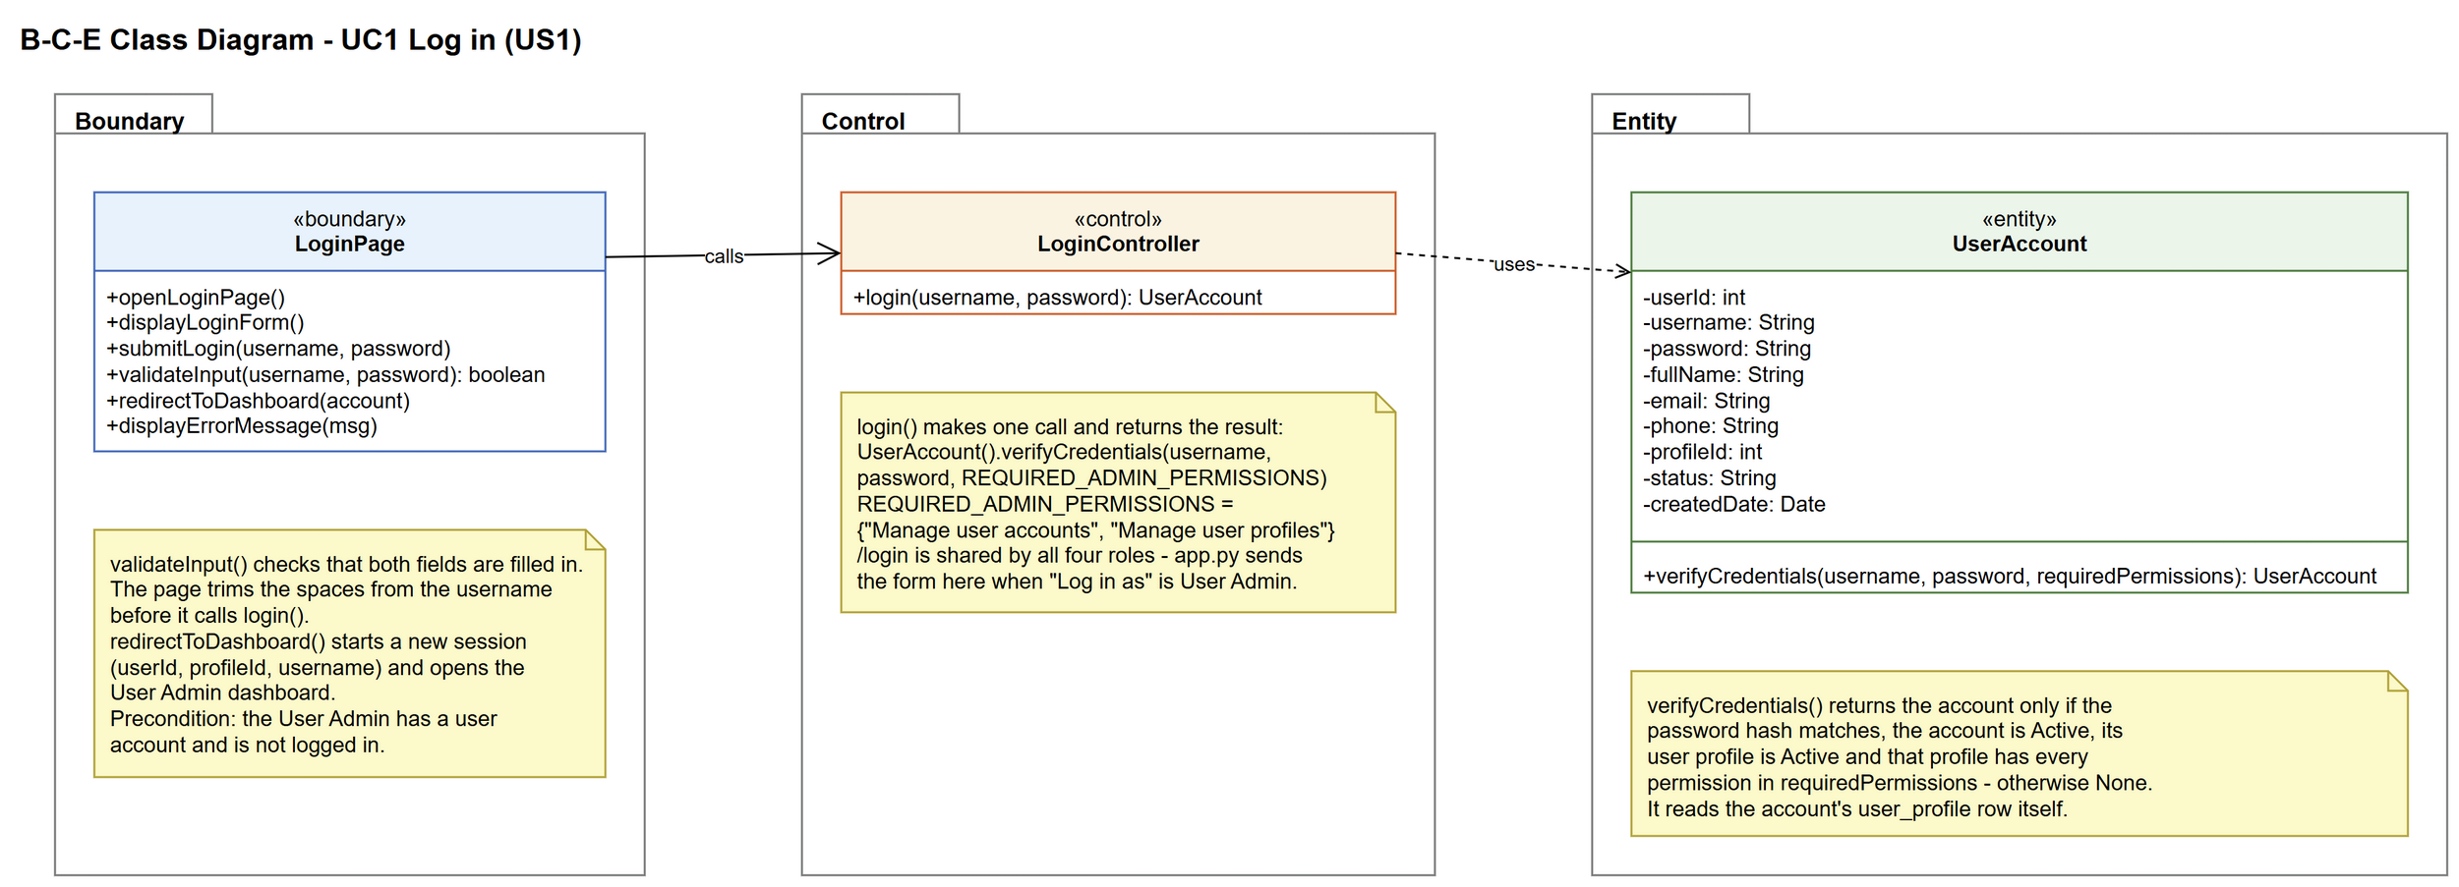
Figure 5: B-C-E class diagram for US1 Log in
Layer | Class | What it does
Boundary | LoginPage | The login screen. Shows the form, checks that both fields are filled in, trims the username, sends the details to the controller, then either starts the session and goes to the User Admin dashboard or shows an error.
Control | LoginController | Controller for UC1. login() just calls UserAccount.verifyCredentials(username, password, REQUIRED_ADMIN_PERMISSIONS) and returns the result: the account, or None if the login is not allowed.
Entity | UserAccount | A user's account. verifyCredentials() returns the account only if the password hash matches, the account is Active, its user profile is Active and that profile has every required permission. It reads the profile row itself, so no other entity class is needed.

6. Sequence diagram
The sequence diagram follows the basic flow of UC1. The outer alt covers alternative flow 4a: an empty field is caught by the page, so the controller is never called. If the input is valid, the page trims the username and calls login(), which makes one call to UserAccount.verifyCredentials() with the User Admin permissions. The entity checks the password, that the account and its profile are Active and that the profile is a User Admin profile (steps 5-7). The inner alt shows the two endings: the session is started and the User Admin goes to the dashboard (step 8), or the error message is shown (alternative flows 5a, 6a, 7a and 7b).
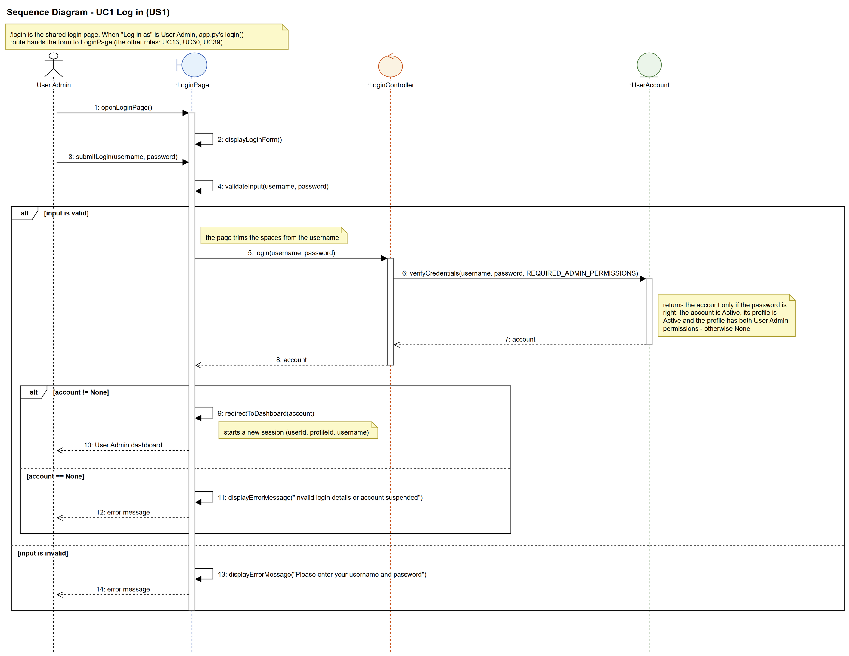
Figure 6: Sequence diagram for UC1 Log in

7. Test cases
Test data used below: user profiles User Admin (id 1), Interior Designer (id 2), Customer (id 3) and Platform Manager (id 4), all Active. User accounts admin01 / Admin@123 (User Admin, Active), admin02 / Admin@123 (User Admin, Suspended), designer1 / Pass@123 (Interior Designer, Active) and cust001 / Cust@123 (Customer, Active).

7a. System test cases (black box)
Equivalence partitioning and boundary value analysis were used to pick the test data. Fill in "Actual result" and "Pass/Fail" after running each test.
Test ID | Scenario | Prerequisites | Test steps | Test data | Expected result | Actual result | Pass / Fail
TC1.1 | Log in with the correct details | admin01 is Active and its profile (User Admin) is Active. Not logged in. | 1. Open the login page  2. Enter the username and password  3. Click "Log in" | admin01 / Admin@123 | The User Admin dashboard opens. The header shows "Logged in as admin01 (User Admin)".
TC1.2 | Wrong password | admin01 exists. | 1. Open the login page  2. Enter the details  3. Click "Log in" | admin01 / Wrong@999 | "Invalid login details or account suspended" is shown. Still on the login page, username kept, password cleared.
TC1.3 | Username does not exist | No account called nobody99. | Same as TC1.2 | nobody99 / Admin@123 | Same message as TC1.2. Not logged in.
TC1.4 | Username left empty | - | 1. Leave the username empty  2. Enter a password  3. Click "Log in" | (empty) / Admin@123 | "Please enter your username and password" is shown. Not logged in.
TC1.5 | Password left empty | - | 1. Enter a username  2. Leave the password empty  3. Click "Log in" | admin01 / (empty) | Same message as TC1.4. Not logged in.
TC1.6 | Suspended user account | admin02's status is Suspended. | Same as TC1.2 | admin02 / Admin@123 | "Invalid login details or account suspended" is shown. Not logged in.
TC1.7 | Account in a suspended user profile | admin01 is Active but the User Admin profile is set to Suspended in the database. | Same as TC1.2 | admin01 / Admin@123 | Same message as TC1.6. Not logged in.
TC1.8 | Password is hidden | - | 1. Type a password into the password box | Admin@123 | Dots are shown instead of the password.
TC1.9 | Account that is not a User Admin | cust001 is Active and its profile (Customer) is Active. | Same as TC1.2 | cust001 / Cust@123 | "Invalid login details or account suspended" is shown. Not logged in (a customer picks Customer in "Log in as", US30). | "Invalid login details or account suspended" was shown. Not logged in. | Pass
TC1.10 | Spaces around the username | admin01 is Active. | Same as TC1.2 | " admin01 " / Admin@123 | The User Admin dashboard opens (the page trims the spaces). | The User Admin dashboard opened (the username was trimmed). | Pass

7b. Unit test cases (for TDD)
These are written before the code (test-driven development) and run with pytest (python -m pytest). They cover normal inputs, abnormal inputs and boundary values.
Test ID | Class and method | Input / setup | Expected output | Type | Pass / Fail
UT1.1 | UserAccount.verifyCredentials() | "admin01", "Admin@123", REQUIRED_ADMIN_PERMISSIONS | Returns admin01's UserAccount | Normal | Pass
UT1.1b | UserAccount.verifyCredentials() | "admin01", "Admin@123", REQUIRED_ADMIN_PERMISSIONS | The returned account's password is the stored hash, not "Admin@123" | Normal | Pass
UT1.2 | UserAccount.verifyCredentials() | "admin01", "Wrong@999", REQUIRED_ADMIN_PERMISSIONS | Returns None | Abnormal | Pass
UT1.3 | UserAccount.verifyCredentials() | "nobody99", "Admin@123", REQUIRED_ADMIN_PERMISSIONS | Returns None | Abnormal | Pass
UT1.4 | UserAccount.verifyCredentials() | "", "", REQUIRED_ADMIN_PERMISSIONS | Returns None (no error thrown) | Abnormal | Pass
UT1.5 | UserAccount.verifyCredentials() | "admin02", "Admin@123", REQUIRED_ADMIN_PERMISSIONS (account Suspended) | Returns None | Abnormal | Pass
UT1.5b | UserAccount.isActive() | UserAccount with status "Active" / with status "Suspended" | Returns True / returns False | Normal | Pass
UT1.6 | LoginController.login() | "admin01", "Admin@123" | Returns admin01's UserAccount (not None) | Normal | Pass
UT1.7 | LoginController.login() | "admin02", "Admin@123" (account suspended) | Returns None | Abnormal | Pass
UT1.8 | LoginController.login() | "admin01", "Admin@123" with the User Admin profile set to Suspended | Returns None | Abnormal | Pass
UT1.9 | LoginPage.validateInput() | "admin01", "" | Returns False | Boundary | Pass
UT1.9b | LoginPage.validateInput() | "", "Admin@123" | Returns False | Boundary | Pass
UT1.10 | LoginPage.validateInput() | "admin01", "Admin@123" | Returns True | Normal | Pass
UT1.11 | LoginController.login() | "cust001", "Cust@123" (Active customer, not a User Admin) | Returns None | Abnormal | Pass
UT1.12 | LoginPage.submitLogin() (POST /login) | " admin01 ", "Admin@123" | The username is trimmed and admin01 is logged in (redirect to /dashboard) | Boundary | Pass
UT1.12b | LoginPage.submitLogin() (POST /login) | "admin01", "Wrong@999" | "Invalid login details or account suspended" is shown. The username box keeps "admin01" and the password is not shown again. | Abnormal | Pass
UT1.13 | login.html (GET /login) | No role in the URL | "Log in as" lists User Admin, Interior Designer, Customer and Platform Manager; User Admin is picked | Normal | Pass
UT1.14 | openLoginPage() of each role's page (GET /login?role=...) | role = admin, designer, customer, manager | That role (and only that role) is picked | Normal | Pass
UT1.15 | LoginPage.openLoginPage() (GET /login?role=hacker) | Unknown role in the URL | Falls back to User Admin picked | Abnormal | Pass
UT1.16 | Old login addresses (GET) | /designer/login, /customer/login, /manager/login | HTTP 302 to /login?role=designer / customer / manager | Normal | Pass
UT1.17 | login() route -> each role's submitLogin() (POST /login) | admin01, designer1, cust001, manager39 with their own role picked | Each one goes to their own dashboard and the session has their username | Normal | Pass
UT1.18 | login() route -> submitLogin() (POST /login) | cust001 as User Admin, admin01 as Customer, cust001 as Interior Designer, designer1 as Platform Manager | "Invalid login details..." is shown, the picked role stays picked, no userId in the session | Abnormal | Pass
UT1.19 | login() route (POST /login) | admin01 / Admin@123 with no role field sent | Treated as User Admin - logs in to /dashboard | Boundary | Pass
UT1.20 | login() route (POST /login) | role = hacker | "Please choose who you are logging in as" (MSG_CHOOSE_ROLE), not logged in | Abnormal | Pass
UT1.21 | submitLogin() of every role (POST /login) | Empty username and password, each role | "Please enter your username and password" | Abnormal | Pass
UT1.22 | Designer / customer / manager logout pages | POST /designer/logout, /customer/logout, /manager/logout | Ends on the shared login page with that role picked and the logout message | Normal | Pass

